Sea Ice Phase 1 CAB

Specific requirements:

* 3 Tier Architecture
* Multiple Spanning Tree
* $200,000 budget

3 Tier Architecture:

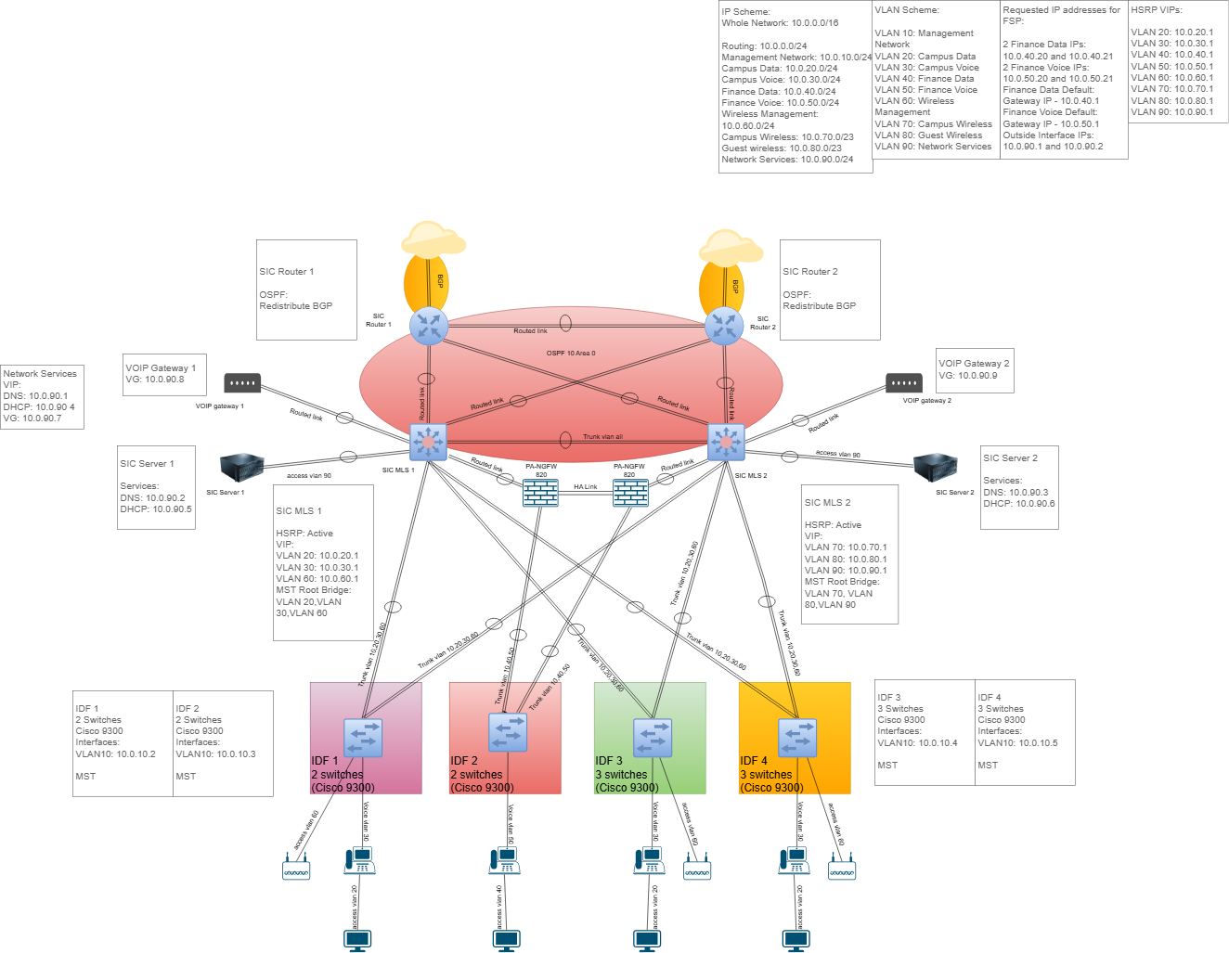

Concerns:

* Budget
* No bottlenecks
* Maximizing use of devices

MST Configuration:

IDF1:

Switch1(config)#spanning-tree mode mst

Switch1(config)#spanning-tree mst configuration

Switch1(config-mst)#name SIC-MST

Switch1(config-mst)#revision 1

Switch1(config-mst)#instance 1 vlan 20,30,60

Switch1(config-mst)#instance 2 vlan 70,80,90

Switch1(config-mst)#end

IDF2:

Switch2(config)#spanning-tree mode mst

Switch2(config)#spanning-tree mst configuration

Switch2(config-mst)#name SIC-MST

Switch2(config-mst)#revision 1

Switch2(config-mst)#instance 1 vlan 20,30,60

Switch2(config-mst)#instance 2 vlan 70,80,90

Switch2(config-mst)#end

IDF3:

Switch3(config)#spanning-tree mode mst

Switch3(config)#spanning-tree mst configuration

Switch3(config-mst)#name SIC-MST

Switch3(config-mst)#revision 1

Switch3(config-mst)#instance 1 vlan 20,30,60

Switch3(config-mst)#instance 2 vlan 70,80,90

Switch3(config-mst)#end

IDF4:

Switch4(config)#spanning-tree mode mst

Switch4(config)#spanning-tree mst configuration

Switch4(config-mst)#name SIC-MST

Switch4(config-mst)#revision 1

Switch4(config-mst)#instance 1 vlan 20,30,60

Switch4(config-mst)#instance 2 vlan 70,80,90

Switch4(config-mst)#end

SIC MLS 1:

SIC MLS 1(config)#spanning-tree mode mst

SIC MLS 1(config)#spanning-tree mst 1 priority 4096

SIC MLS 1(config)#spanning-tree mst 2 priority 8192

SIC MLS 1(config)#spanning-tree mst configuration

SIC MLS 1(config-mst)#name SIC_STP

SIC MLS 1(config-mst)#revision 1

SIC MLS 1(config-mst)#instance 1 vlan 20,30,60

SIC MLS 1(config-mst)#instance 2 vlan 70,80,90

SIC MLS 1(config-mst)#end

SIC MLS 2:

SIC MLS 2(config)#spanning-tree mode mst

SIC MLS 2(config)#spanning-tree mst 1 priority 8192

SIC MLS 2(config)#spanning-tree mst 2 priority 4096

SIC MLS 2(config)#spanning-tree mst configuration

SIC MLS 2(config-mst)#name SIC_STP

SIC MLS 2(config-mst)#revision 1

SIC MLS 2(config-mst)#instance 1 vlan 20,30,60

SIC MLS 2(config-mst)#instance 2 vlan 70,80,90

SIC MLS 2(config-mst)#end

Budget:

Concerns:

* Where should I focus more money?
* Where can I save money?